The Effects of Auckland’s Metropolitan Urban Limit on Land Prices

Guanyu Zheng[1]

New Zealand Productivity Commission

Abstract

This paper estimates the impact of Auckland’s Metropolitan Urban Limit (MUL) on land values in the greater Auckland region. The model extends Grimes and Liang (2009) which analysed the effects of the MUL on mean land values across Auckland. This paper, instead, uses quantile regression and focuses on land price deciles. The major advantage of quantile regression is to provide a comprehensive analysis of central tendency (e.g. median) and dispersion (e.g. lower or upper quartile) on the relationship between the variables. The results suggest that the impact of Auckland’s MUL is statistically significant and uneven across land price deciles, with a greater impact on lower decile land prices.

**Introduction**

The housing boom in the 2000s saw an unprecedented escalation in New Zealand house prices and deteriorating housing affordability. Real house prices almost doubled between 2001 and 2007, an average increase of approximately 12% per year. The steep increase in real house price has decreased the likelihood of households being able to purchase their own home and begin the climb up the property ladder. The Auckland region has 31% and 41% of New Zealand’s housing stock by number and value respectively. During the house price boom, the gap between house prices in Auckland and the rest of the country widened even further. The Auckland region faces the highest housing affordability pressures in the country (New Zealand Productivity Commission 2012).

Section prices have grown more quickly than house prices over the last twenty years suggesting that land supply has become less responsive to increasing demand for housing. Pressure on land prices has been particularly acute in Auckland – land accounts for around 60% of the cost of a new house in Auckland compared to 40% of the cost of building a new house in the rest of New Zealand (Figure 1).

Increasing house prices are indicative of supply side rigidities. Contributing factors include the availability of buildable land. Gyouroko (2009) notes that the strong positive relationship between restrictive land use policies and house prices is well-established.

In Auckland, the Metropolitan Urban Limit (MUL) is a zoning restriction that defines “the boundary of the urban area with the rural part of the region”. Grimes and Liang (2009) found that the impact of the MUL was significant. Land prices just inside the MUL were 10 times higher than land just outside MUL. The New Zealand Productivity Commission applied a similar methodology to estimate the impact of the MUL between 1995 and 2010. The Commission found that the value of land just inside the MUL boundary is almost 9 times greater than land just outside the boundary, indicating that the MUL is a binding constraint on land supply. Further, the value of the land price differential has increased since the late 1990s, indicating that the MUL has become increasingly binding as housing demand has intensified in Auckland city.

Figure 1. Housing theme: Auckland region v.s. selected New Zealand cities:

(left) Growth of real land and capital values in 2000-2007

(right) land value as a share of house value in 2000 and 2007

|  |  |
| --- | --- |
|  |  |

*Source: QVNZ*

Figure 2. The impact of the Auckland MUL on land prices

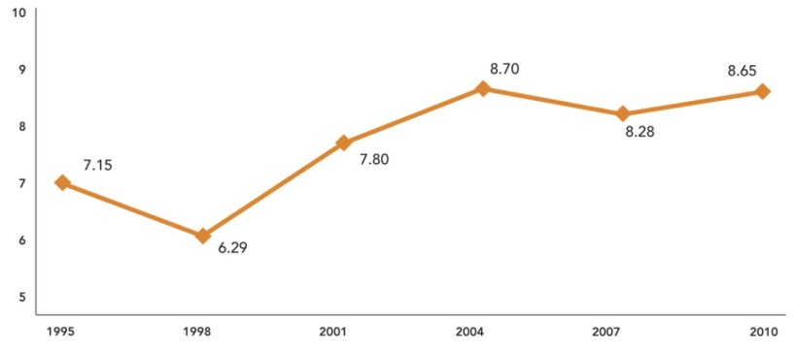

*Source: New Zealand Productivity Commission*

Note: The price multiple of land 2km within the MUL to land 2km outside the MUL

This paper investigates whether the impact of the MUL is *uneven* across land price deciles. The Commission’s inquiry into housing affordability generated a particular interest in whether the MUL contributed to higher prices (and declining affordability) of lower quartile and median valued land than more expensive properties. One possible explanation for this difference could be that the demand for lower decile residential properties is higher than more expensive properties at the urban limit.

**Method**

This section outlines the regression model used to estimate the impact of Auckland’s MUL on land prices in the region. The model extends the modelling work of Grimes and Liang (2009) using quantile regression[2] and focuses on land price deciles.

Traditional regression analysis (e.g. Ordinary Least Square) is focused on the conditional means. That summarises the relationship between the response variable and predictor variables by describing the mean of the response for each fixed value of the predictors (Hao & Naiman, 2007). However, the conditional-mean framework cannot be extended to non-central locations (e.g. lower and upper quartiles) that may fail to capture informative trends in the response distribution. Alternatively, quantile regression (Koenker & Bassett, 1978; Koenker, 2005) uses a conditional-quantile framework that is able to provide a comprehensive data analysis on quantiles. It also makes no distributional assumption about the error term in the model. That gives greater flexibility in modelling heterogeneous data.

In this study, the hypothesis is that the impact of Auckland MUL will be uneven across the board. In particular, areas with cheaper than average land values experience a greater impact. Quantile regression is more suitable than ordinary linear regression to test this hypothesis.

In the regression, real median land prices[3] ($ per hectare) are modelled at the meshblock level across the former seven Auckland territorial authorities – Rodney, North Shore, Waitakere, Auckland city, Manukau, Papakura and Franklin – around 8,000 meshblocks[4] each year.

These prices were based on the land value portion of Quotable Value residential property valuations. The median land values are weighted medians for two main types of properties – residential dwellings and lifestyle dwellings. These properties usually have detached or semi-detached dwellings on clearly defined sections and make up over 70% of the total number and value of dwellings in the Auckland region. For other types of dwellings, land is usually cross-leased or not clearly defined. In these cases, assessments of land area are difficult to measure because there is no legally assigned portion to the land parcel, like a flat or apartment. These dwellings were therefore excluded from the analysis.

The key variables of interest in the model are the MUL dummy variables. The dummy variables were constructed on the basis of meshblock distance from the MUL boundaries. Specifically, each meshblock was assigned into one of four categories depending on its distance to the MUL. The categories are: greater than 2km inside the MUL, 2km within the MUL, 2km outside the MUL, and greater than 2km outside the MUL. If a meshblock was dissected by the MUL, it was randomly assigned to either just inside or outside MUL by a uniform distribution[5]. This study used the 2009 MUL boundary[6] and assumed that it remained constant over time. Although this is not the case in reality, changes of MUL over the last 15 years have been relatively minor (Appendix 1).

The regression includes a set of locational factors which removed large-scale variations in land values associated with geographical locations. These locational factors are territorial authority (TA) dummies, urban area dummies and latitude-longitude. TA dummies consist of Rodney, North Shore, Waitakere, Manukau, Papakura and Franklin. Urban area dummies were derived from rural and urban profiles from the 2006 Census (Statistics New Zealand). Rural areas were defined as rural areas with high, moderate or low urban influence. The local centric nodes include a set of high business centres that recognise a polycentric Auckland region[7]. Quadratic terms of latitude and longitude, including the interaction term, were used to capture the distributional effect of land values associated with location[8].

The following regression was estimated:

$Q\left[Y | X,q\right]=X^{,}β_{q}$ such that $prob\left[Y-X^{,}β_{q}≤0 | X\right]=q, 0<q<1$

Y and X are dependent and independent variables. $Q\left[Y | X,q\right]$ is a function of quantile regression with regard to specific quantile q.

$\ln\left({RLV}_{i}\right)= θ_{2}{MUL}_{2}+ θ_{3}{MUL}_{3}+ θ_{4}{MUL}_{4}+ \sum_{j=1}^{J}{β_{j}{NOD}_{j}+} π_{1}URBAN+ ρ_{4}{TA}_{4}+ρ_{5}{TA}_{5}+ ρ_{6}{TA}_{6}+ρ_{8}{TA}_{8}+ρ_{9}{TA}_{9}+ρ_{10}{TA}_{10}+ π_{1}LON+π_{2}LAT+{π_{3}LON}^{2}+{π_{4}LAT}^{2}+π_{5}LON*LAT+α+ε_{i}$

(1)

Where,

Ln(RLV) is log real median land value per hectare in meshblock i at 1995 price.

MUL is MUL dummies. MUL2, MUL3 and MUL4 represent meshblocks just inside MUL within 2km, just outside MUL within 2km and greater 2km outside MUL. MUL1, well inside MUL, is set to be a baseline.

TA is TA dummies. TA4, TA5, TA6, TA8, TA9 and TA10 represent Rodney, North Shore, Waikakere, Manukau, Papakura, Franklin. Auckland city, TA7, is set to a baseline.

URBAN is an urban dummy. It is defined by Census classification in 2006.

NOD is local centric node dummy variable. NOD=1 when a meshblock is no more than 5km away from the centric node. Otherwise, NOD=0.

LAT and LON represent latitudes and longitudes of central meshblock. They have linear, quadratic and interaction terms.

$α$ is the intercept

$ε$ is residuals that are assumed to be independently distributed.

**Data**

Historic land value data from 1995 to 2010 was sourced by Quotable Value New Zealand (QVNZ). The valuation data in the QVNZ series provides capital, land and improvement values as well as land area and type. However, these values are only updated when re-valuations are carried out. That normally occurs in a three-year cycle, and dates varied slightly different across the territorial authorities. Linear interpolation was applied to obtain estimated land prices between valuation cycles. Interpolation required another QVNZ dataset – sales data[9] – to indicate price movement. There are two main assumptions for interpolation: 1) land prices are strictly correlated with sale prices and 2) movements of land prices at meshblocks within the same territorial authority are identical. The first assumption was made to match movement of land prices with sales prices. And the second assumption was made as sales price at meshblock level was unavailable.

The method of linear interpolation is done in the following equation (2).

$L_{t+i}=L_{t}+\left( L_{t+c}-L_{t} \right)\left(\frac{S_{t+i}-S_{t}}{S_{t+c}-S_{t}}\right)$ (2)

Scripts L and S are land prices and sales price index. Sub-scripts t and c represent the first year of valuation and the length of cycle (e.g. 2, 3 or 4). Subscript i represents the time period of interpolation, that falls between t and t + c.

Under the equation, interpolated land prices ($L_{t+i}$) are calculated in two parts. The first part is the observed land price at the beginning of the valuation year ($L_{t}$). The second part calculate value growth between valuation years. That discounts the observed increment between cycles $\left( L_{t+c}-L_{t} \right)$ by the proportion of incremental change of sale price index over the same period $\left(\frac{S_{t+i}-S_{t}}{S_{t+c}-S_{t}}\right)$.

Since the valuation data is obtained triennially, data and results from modelling are reported for every third year: 1995, 1998, 2001, 2004, 2007 and 2010. Real land prices are calculated on the basis of 1995 constant prices using New Zealand’s CPI.

The following tables (table 1 – 3) provide summary statistics on real land prices by quantiles and MUL groups and reveal a number of key results:

1. Land prices decline from MUL1 to MUL4, that is, from well inside the MUL to well outside (more than 2km) the MUL. This is partially associated with distances to the Auckland CBD.
2. Step price changes are associated with the MUL boundary for lower-quantile and median priced land. In 1995-2010, relative price differences between MUL2 (within 2km inside the MUL) and MUL3 (within 2 km just outside the MUL) were 7 for lower quartile and 3.5 for median priced land (Figure 4).
3. Lower-quartile and median priced land in MUL2 (within 2km inside the MUL) experienced the highest growth rates. In comparison, price growth for land in MUL3 (within 2km outside the MUL) is the lowest. This suggests that the land price impact of the MUL has been increasing and concentrated on cheaper land located around the boundaries.

Table 1: Real lower-quartile land price per hectare (based on 1995 price) by MUL

|  |  |  |  |  |  |  |  |  |
| --- | --- | --- | --- | --- | --- | --- | --- | --- |
| Lower-Quartile | 1995 | 1998 | 2001 | 2004 | 2007 | 2010 | Count | %change  95 - 10 |
| MUL1 | 612,006 | 599,128 | 867,115 | 1,193,720 | 2,164,494 | 2,531,960 | 5,416 | 314% |
| MUL2 | 405,205 | 375,952 | 462,086 | 765,334 | 1,379,914 | 1,726,659 | 2,294 | 326% |
| MUL3 | 47,766 | 58,149 | 72,782 | 89,907 | 144,313 | 184,590 | 2,22 | 286% |
| MUL4 | 24,507 | 30,712 | 38,161 | 51,623 | 85,604 | 98,995 | 879 | 304% |

Table 2: Real median land price per hectare (based on 1995 price) by MUL

|  |  |  |  |  |  |  |  |  |
| --- | --- | --- | --- | --- | --- | --- | --- | --- |
| Median | 1995 | 1998 | 2001 | 2004 | 2007 | 2010 | Count | %change  95-10 |
| MUL1 | 956,702 | 1,039,128 | 1,461,094 | 2,035,915 | 3,470,675 | 3,534,351 | 5,416 | 269% |
| MUL2 | 492,288 | 476,459 | 637,069 | 965,015 | 1,868,390 | 2,077,143 | 2,294 | 322% |
| MUL3 | 109,866 | 120,873 | 169,622 | 214,852 | 370,284 | 380,311 | 222 | 246% |
| MUL4 | 52,182 | 65,504 | 80,624 | 109,121 | 197,555 | 215,803 | 879 | 314% |

Table 3: Real upper-quartile land price per hectare (based on 1995 price) by MUL

|  |  |  |  |  |  |  |  |  |
| --- | --- | --- | --- | --- | --- | --- | --- | --- |
| Upper-Quartile | 1995 | 1998 | 2001 | 2004 | 2007 | 2010 | Count | %change  95-10 |
| MUL1 | 1,520,958 | 1,815,876 | 2,491,920 | 3,615,172 | 5,511,004 | 5,392,102 | 5,416 | 255% |
| MUL2 | 689,022 | 818,923 | 1,060,365 | 1,485,820 | 2,836,567 | 2,896,644 | 2,294 | 320% |
| MUL3 | 386,102 | 412,105 | 578,933 | 780,399 | 1,161,163 | 1,649,450 | 222 | 327% |
| MUL4 | 234,466 | 270,333 | 326,978 | 563,465 | 1,064,863 | 1,183,199 | 879 | 405% |

Figure 3. Relative price difference on MUL, 1995-2010

Note: MUL1 – land well inside MUL

MUL2 – land just inside MUL (within 2km)

MUL3 – land just outside MUL (within 2km)

MUL4 – land 2km outside MUL

**Results**

This section details regression results (OLS and quantile regressions) on the effects of the MUL boundary on real land prices from 1995-2010. Some detailed regression estimates are presented in appendix 2.

The results suggest that spatial correlation is statistically significant. The presence of spatial correlation may either bias coefficient estimates or make inefficient estimates (Anselin, 1988). Bootstrapping was undertaken on both OLS and quantile regressions suggesting the latter problem i.e. coefficient estimates remain unbiased, but are less efficient on standard errors (Appendix 3).

The impact of the MUL is assessed by comparing the value of land situated just inside the MUL relative to land situated just outside the MUL, as measured by the difference[10] between the coefficient on MUL2 and MUL3. Both OLS and quantile regression show similar impact of MUL on mean and median, around 5-6 times (see figure 4 and 5). Figure 5 also reveals the impact of the MUL is uneven with land in lower decile range experiencing the highest impact. On average, the price difference in the lowest decile is around 10 which is 1.8 and 6.9 times greater than for land in the median and highest deciles.

Over the time period, the impact of the MUL on the lowest decile land and median land increased. In 1995, the impact on the lowest decile and median were 8.1 and 4.3 respectively. In 2010, both increased to 9.7 and 5.6, up 20% and 30%. Conversely, the impact on the highest decile remained relatively flat, just 1.3. This indicates that most of the binding constraint from the MUL falls on the lowest to median valued land. Consequently, price gaps between less and more expensive land have widened (Figure 6).

Figure 4. Relative price differences between MUL2 and MUL3 from OLS regressions

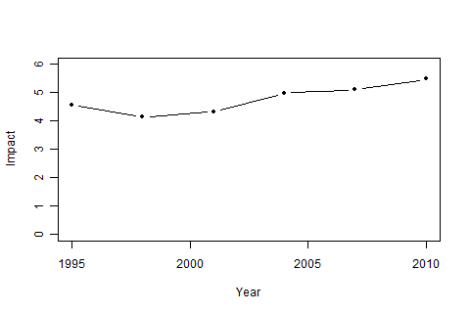

Figure 5. Relative price differences between MUL2 and MUL3 from quantile regressions

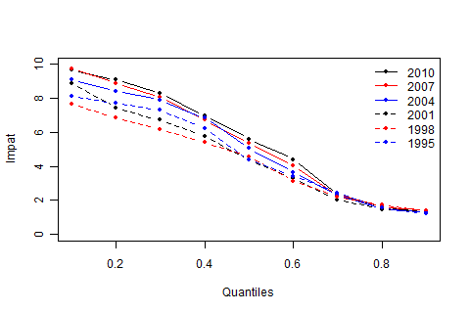

Figure 6. Growth gaps from quantile regressions  
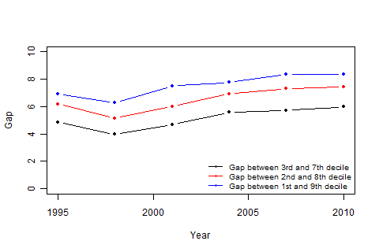

For land situated in urban and rural areas[11], price differences are relative minor and stable through the period (figure 6 and figure 7). Particularly in urban areas, price differences are around 1. This implies that urban and rural land prices grow at similar rates and the MUL does not intensify price pressures onto inner urban and remote rural areas.

Figure 7. Relative price differences between MUL1 and MUL2

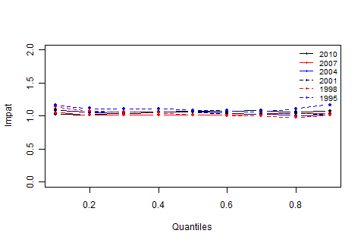

Figure 8. Relative price differences between MUL3 and MUL4

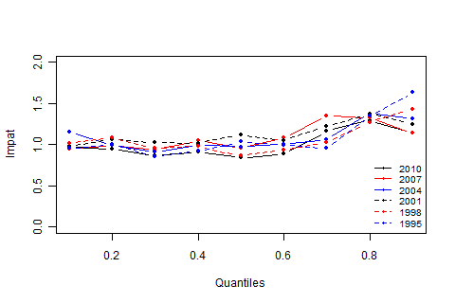

**Conclusion**

The containment of Auckland city through the Metropolitan Urban Limit is a supply side rigidity that puts pressure on residential land prices, in particular around the MUL boundaries.

The MUL is a binding constraint on land supply. The value of the land price differential has increased since the late 1990s, indicating that the MUL has become increasingly binding as housing demand has intensified in Auckland region.

This study shows that the impact of the MUL is uneven. The impact on the lower-quartile land price range is the highest, suggesting that the MUL has a profound effect on housing affordability for those at the lower end of the housing market.

**References**

Anselin, L. (1988) Spatial Econometrics: Methods and Models, Dordrecht: Kluwer Academic

Cliff, A. D., Ord, J. K. 1981 Spatial processes, Pion

Efron, B. (1979). "Bootstrap Methods: Another Look at the Jackknife". *The Annals of Statistics* **7** (1): 1–26

Grimes, A. & Liang, Y. (2009) ‘Spatial Determinants of Land Prices in Auckland: Does the Metropolitan Urban Limit Have an Effect?’, Applied Spatial Analysis and Policy, 2:1, 23-45

Gyourko, J., Saiz, A. and Summers, A., (2008). “A new measure of the local regulatory environment for housing markets: the Wharton Residential Land Use regulatory Index. Urban Studies, 45(3), 693-729

Gyourko, J., (2009). “Housing supply”. Annual Review of Economics, 1, pp.295-318.

Hao, L. & Naiman, Q, D. (2007). Quantile regression, Sage publications

Koenker, R. and Bassett, G. “Regression Quantiles", Econometrica, vol 46, 33-50, 1978.

Moran, P. A. P. (1950). "Notes on Continuous Stochastic Phenomena". *Biometrika* **37** (1): 17–23.

Motu Economic and Public Policy Research. (2007) “housing supply in the Auckland region 2000-2005”, Centre for Housing Research

New Zealand Productivity Commission (2012). ‘Housing affordability inquiry’. <http://www.productivity.govt.nz/inquiry-content/1509>

Newey, W.K., Powell, J. L. (1990) “Efficient estimation of linear and type I censored regression models under conditional quantile restrictions”, Econometric theory 6(3), 295-317

Appendix 1: MUL regions in the Auckland region

Please note. Legend 1, 2, 3 and 4 in each graph represent MUL1, MUL2, MUL3 and MUL4.







|  |
| --- |
| Appendix 2: Coefficient estimates on quantile regression  Please note, tau represent deciles  *** p<0.01, **p<0.05, * p<0.1 |

|  |  |  |  |  |  |  |  |  |  |  |  |  |  |  |  |  |  |  |  |  |  |  |  |  |  |  |  |  |  |  |
| --- | --- | --- | --- | --- | --- | --- | --- | --- | --- | --- | --- | --- | --- | --- | --- | --- | --- | --- | --- | --- | --- | --- | --- | --- | --- | --- | --- | --- | --- | --- |
|  | | 1995 | | | | | | | | | | | | | | | | | | 1998 | | | | | | | | | | |
|  | | tau= 0.1 | | tau= 0.2 | | tau= 0.3 | | tau= 0.4 | | tau= 0.5 | | tau= 0.6 | | tau= 0.7 | | tau= 0.8 | | tau= 0.9 | | tau= 0.1 | | tau= 0.2 | | tau= 0.3 | tau= 0.4 | tau= 0.5 | tau= 0.6 | tau= 0.7 | tau= 0.8 | tau= 0.9 |
| tla1 | | -0.79*** | | -0.77*** | | -0.83*** | | -0.84*** | | -0.87*** | | -0.84*** | | -0.92*** | | -1.01*** | | -0.98*** | | -0.43*** | | -0.45*** | | -0.53*** | -0.56*** | -0.64*** | -0.75*** | -0.89*** | -1.05*** | -1.24*** |
| tla2 | | 0.04 | | 0.03 | | 0.01 | | 0.00 | | -0.03 | | -0.03 | | -0.05*** | | -0.04 | | -0.02 | | 0.23** | | 0.19*** | | 0.12** | 0.08 | 0.02 | -0.04 | -0.12* | -0.20** | -0.29** |
| tla3 | | -0.61*** | | -0.60*** | | -0.59*** | | -0.63*** | | -0.68*** | | -0.71*** | | -0.72*** | | -0.81*** | | -0.96*** | | -0.49*** | | -0.50*** | | -0.54*** | -0.58*** | -0.62*** | -0.66*** | -0.76*** | -0.87*** | -1.05*** |
| tla5 | | -0.03*** | | -0.12** | | -0.15** | | -0.20** | | -0.30*** | | -0.39*** | | -0.52*** | | -0.61*** | | -0.70*** | | -0.10* | | -0.22*** | | -0.24*** | -0.32*** | -0.46*** | -0.52*** | -0.69*** | -0.90*** | -1.13*** |
| tla6 | | -0.23*** | | -0.45*** | | -0.50*** | | -0.51*** | | -0.52*** | | -0.45*** | | -0.56*** | | -0.54*** | | -0.57*** | | -0.30*** | | -0.61*** | | -0.68*** | -0.52*** | -0.74*** | -0.69*** | -0.82*** | -0.97*** | -1.23*** |
| tla7 | | -0.10** | | -0.12** | | -0.16** | | -0.13** | | -0.24*** | | -0.26*** | | -0.52*** | | -0.48*** | | -0.44*** | | 0.07 | | -0.06 | | 0.05 | -0.03 | -0.20** | -0.23*** | -0.53*** | -0.57*** | -0.90*** |
| MUL2 | | -0.15* | | -0.11* | | -0.10* | | -0.10* | | -0.09 | | -0.08 | | -0.06 | | -0.10 | | -0.16* | | -0.14* | | -0.07 | | -0.06 | -0.04 | -0.02 | -0.01 | 0.00 | 0.02 | -0.01 |
| MUL3 | | -2.25*** | | -2.15*** | | -2.09*** | | -1.93*** | | -1.57*** | | -1.30*** | | -0.95*** | | -0.54*** | | -0.37*** | | -2.18*** | | -2.00*** | | -1.88*** | -1.73*** | -1.54*** | -1.15*** | -0.79*** | -0.52*** | -0.35*** |
| MUL4 | | -2.20*** | | -2.16*** | | -1.93*** | | -1.85*** | | -1.60*** | | -1.30*** | | -0.91*** | | -0.83*** | | -0.86*** | | -2.19*** | | -2.08*** | | -1.84*** | -1.71*** | -1.39*** | -1.08*** | -0.81*** | -0.76*** | -0.72*** |
|  | |  | |  | |  | |  | |  | |  | |  | |  | |  | |  | |  | |  |  |  |  |  |  |  |
|  | 2001 | | | | | | | | | | | | | | | | | | 2004 | | | | | | | | | | | |
|  | tau= 0.1 | | tau= 0.2 | | tau= 0.3 | | tau= 0.4 | | tau= 0.5 | | tau= 0.6 | | tau= 0.7 | | tau= 0.8 | | tau= 0.9 | | tau= 0.1 | | tau= 0.2 | | tau= 0.3 | | tau= 0.4 | tau= 0.5 | tau= 0.6 | tau= 0.7 | tau= 0.8 | tau= 0.9 |
| tla1 | -0.87*** | | -0.84*** | | -0.89*** | | -0.88*** | | -0.92*** | | -0.98*** | | -1.07*** | | -1.19*** | | -1.22*** | | -0.97*** | | -1.11*** | | -1.15*** | | -1.18*** | -1.25*** | -1.34*** | -1.44*** | -1.61*** | -1.61*** |
| tla2 | -0.42*** | | -0.47*** | | -0.48*** | | -0.47*** | | -0.50*** | | -0.49*** | | -0.53*** | | -0.56*** | | -0.59*** | | -0.47*** | | -0.53*** | | -0.56*** | | -0.57*** | -0.61*** | -0.66*** | -0.68*** | -0.73*** | -0.73*** |
| tla3 | -0.88*** | | -0.84*** | | -0.84*** | | -0.85*** | | -0.90*** | | -0.91*** | | -0.95*** | | -1.02*** | | -1.15*** | | -0.84*** | | -0.83*** | | -0.86*** | | -0.93*** | -1.01*** | -1.10*** | -1.17*** | -1.29*** | -1.39*** |
| tla5 | -0.81*** | | -0.84*** | | -0.79*** | | -0.81*** | | -0.83*** | | -0.92*** | | -0.99*** | | -1.06*** | | -1.07*** | | -0.52*** | | -0.56*** | | -0.56*** | | -0.64*** | -0.69*** | -0.74*** | -0.81*** | -0.93*** | -1.05*** |
| tla6 | -0.68*** | | -0.75*** | | -0.76*** | | -0.75*** | | -0.62*** | | -0.72*** | | -0.67*** | | -0.64*** | | -0.69*** | | -0.62*** | | -0.80*** | | -0.73*** | | -0.80*** | -0.82*** | -0.85*** | -0.81*** | -0.83*** | -0.93*** |
| tla7 | -0.37*** | | -0.30*** | | -0.25*** | | -0.19** | | -0.33*** | | -0.50*** | | -0.56*** | | -0.69*** | | -0.76*** | | -0.03 | | -0.22*** | | -0.12* | | -0.11* | -0.19** | -0.12* | -0.32*** | -0.47*** | -0.52*** |
| MUL2 | -0.09 | | -0.06 | | -0.06 | | -0.05 | | -0.06 | | -0.04 | | -0.03 | | -0.03 | | -0.03 | | -0.09 | | -0.05 | | -0.06 | | -0.06 | -0.06 | -0.05 | -0.03 | -0.01 | -0.02 |
| MUL3 | -2.28*** | | -2.07*** | | -1.97*** | | -1.81*** | | -1.53*** | | -1.22*** | | -0.74*** | | -0.40*** | | -0.35*** | | -2.29*** | | -2.18*** | | -2.12*** | | -1.98*** | -1.68*** | -1.34*** | -0.86*** | -0.41*** | -0.29*** |
| MUL4 | -2.26*** | | -2.13*** | | -1.99*** | | -1.83*** | | -1.64*** | | -1.28*** | | -0.94*** | | -0.72*** | | -0.57*** | | -2.44*** | | -2.17*** | | -2.03*** | | -1.97*** | -1.66*** | -1.34*** | -0.92*** | -0.73*** | -0.56*** |

|  |  |  |  |  |  |  |  |  |  |  |  |  |  |  |  |  |  |  |
| --- | --- | --- | --- | --- | --- | --- | --- | --- | --- | --- | --- | --- | --- | --- | --- | --- | --- | --- |
|  | 2007 | | | | | | | | | 2010 | | | | | | | | |
|  | tau= 0.1 | tau= 0.2 | tau= 0.3 | tau= 0.4 | tau= 0.5 | tau= 0.6 | tau= 0.7 | tau= 0.8 | tau= 0.9 | tau= 0.1 | tau= 0.2 | tau= 0.3 | tau= 0.4 | tau= 0.5 | tau= 0.6 | tau= 0.7 | tau= 0.8 | tau= 0.9 |
| tla1 | -0.98*** | -1.09*** | -1.12*** | -1.12*** | -1.13*** | -1.25*** | -1.29*** | -1.34*** | -1.46*** | -0.74*** | -0.78*** | -0.79*** | -0.77*** | -0.83*** | -0.88*** | -0.90*** | -1.03*** | -1.20*** |
| tla2 | -0.43*** | -0.44*** | -0.46*** | -0.44*** | -0.44*** | -0.49*** | -0.49*** | -0.48*** | -0.50*** | -0.39*** | -0.39*** | -0.37*** | -0.37*** | -0.40*** | -0.41*** | -0.42*** | -0.46*** | -0.51*** |
| tla3 | -1.13*** | -1.14*** | -1.14*** | -1.14*** | -1.17*** | -1.26*** | -1.31*** | -1.40*** | -1.59*** | -0.45*** | -0.43*** | -0.40*** | -0.46*** | -0.51*** | -0.56*** | -0.61*** | -0.69*** | -0.83*** |
| tla5 | -0.34*** | -0.34*** | -0.32*** | -0.36*** | -0.38*** | -0.42*** | -0.44*** | -0.51*** | -0.54*** | -0.37*** | -0.36*** | -0.34*** | -0.37*** | -0.39*** | -0.41*** | -0.43*** | -0.49*** | -0.54*** |
| tla6 | -0.38*** | -0.45*** | -0.38*** | -0.41*** | -0.48*** | -0.47*** | -0.46*** | -0.53*** | -0.52*** | -0.68*** | -0.73*** | -0.66*** | -0.67*** | -0.66*** | -0.67*** | -0.65*** | -0.68*** | -0.71*** |
| tla7 | 0.05 | 0.05 | 0.16** | 0.20*** | 0.10* | 0.28*** | 0.11** | -0.15** | -0.22*** | -0.33*** | -0.25*** | -0.14** | -0.06 | -0.03 | 0.00 | -0.05 | -0.12** | -0.33*** |
| MUL2 | -0.05 | -0.01 | -0.02 | -0.01 | -0.02 | -0.01*** | -0.03 | -0.04 | -0.04 | -0.03 | -0.02 | -0.04 | -0.06 | -0.07 | -0.07 | -0.08 | -0.06 | -0.08 |
| MUL3 | -2.33*** | -2.20*** | -2.10*** | -1.92*** | -1.69*** | -1.41*** | -0.88*** | -0.51*** | -0.36*** | -2.30*** | -2.23*** | -2.15*** | -2.00*** | -1.80*** | -1.55*** | -0.92*** | -0.55*** | -0.34*** |
| MUL4 | -2.27*** | -2.19*** | -2.04*** | -1.97*** | -1.65*** | -1.49*** | -1.18*** | -0.79*** | -0.49*** | -2.27*** | -2.17*** | -2.01*** | -1.90*** | -1.62*** | -1.43*** | -1.07*** | -0.80*** | -0.47*** |

Appendix 3: Bootstrap study on effects of spatial correlation on ordinary least square and quantile regressions

The main purpose of this bootstrap study is to evaluate whether or not the omission of spatial correlation in OLS and quantile regressions causes bias results.

According to LeSage and Pace (2009), omitted variables may easily arise in spatial modelling because unobservable factors such as location amenities, highway accessibility or neighbourhood prestige may exert an influence on the dependent variable. It is unlikely that explanatory variables are readily available to capture these types of latent influences. If this is the case, regressions may return either bias or inefficient estimates in explanatory variables (Anselin, 1988).

To determine which impact the spatial correlation may affect to OLS and quantile regression estimates, I apply an non-parametric bootstrapping technique (Efron, 1981) to evaluate two measures, (1) measure of spatial correlation and (2) stability of coefficient estimates. Bootstrapping is vital for both measures. (1) spatial correlation on the entire data cannot be calculated. However bootstrapping makes the calculate feasible by resampling the entire data. (2) Under traditional regression analysis, theoretical distribution of the parameters of interest in unknown. Bootstrapping allows to assess the properties of distribution.

The following shows the procedures for these measures. (Note that the bootstrapping study only focuses on 2010 data and run repeatedly 200 times.)

1. Measures of spatial correlation
   1. bootstrapping randomly draw 20% of sample (without replacement) from the entire data
   2. under the sample, run OLS and derive residuals
   3. estimate spatial correlation by Moran’s I(Moran, 1950, Cliff & Ord, 1981)[12][13] test from residuals
2. Stability of coefficient estimates
   1. For OLS
      1. bootstrapping randomly draw 20% of sample (without replacement) from the entire data
      2. under the sample, run OLS and derive coefficient estimates
      3. compute empirical distributions of coefficient estimates and correlations of coefficient estimates and spatial correlation from (1)
   2. For quantile regression
      1. same as i.
      2. under the sample, run quantile regressions on decide and derive coefficient estimates
      3. compute empirical distributions of coefficient estimates

Results: (1) measures of spatial correlation

Results suggest that spatial correlations are statistically significant. But the strength of the correlation is relatively weak, no more than 0.15 (figure A3.1). It possibly indicates the impact on coefficient estimates may be limited due to week spatial correlations.

Results: (2) stability of coefficient estimates

Results focus on key variables, MUL2 and MUL3, which are used to evaluate the MUL boundary effect. For OLS, distributions for both coefficients are normal distributions (figure A3.2) and bivariate relations between coefficients and spatial correlations are uncorrelated (figure A3.3). Similarly bootstrap on quantile regression shows stable and symmetric distributions on MUL coefficients over deciles (figure A3.4).These results gives some confidences that coefficient estimates are stable and are not influenced by spatial correlations. Hence , OLS and quantile regression estimates are unlikely biased, but inefficient in some degrees.

Figure A3.1 Density distribution of spatial correlation

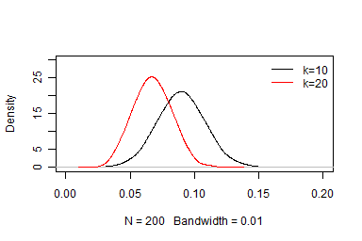

Figure A3.2 Density distributions of MUL2 and MUL3 coefficients

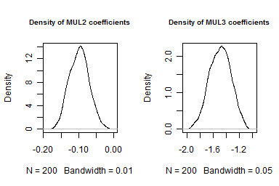

Figure A3.3 Scatter-plots of MUL2 and MUL3 coefficients with spatial correlations

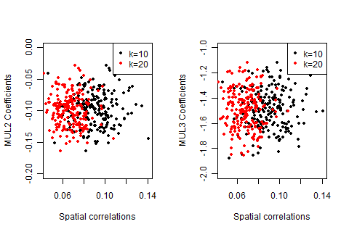

Figure A3.4 Bootstrapped MUL2 and MUL3 coefficients

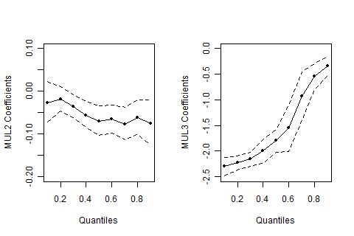

Note: Solid and dash lines represent estimates and 95% bootstrapped confidence interval

1. The views, opinions, findings, and conclusions or recommendations expressed in this paper are strictly those of the author(s). They do not necessarily reflect the views of the New Zealand Productivity Commission or the New Zealand Government.  The New Zealand Productivity Commission and the New Zealand Government take no responsibility for any errors or omissions in, or for the correctness of, the information contained in this paper. The paper is presented not as policy, but with a view to inform and stimulate wider debate. The author can be contacted [Guanyu.zheng@productivity.govt.nz](mailto:Guanyu.zheng@productivity.govt.nz)
2. Use method from Koenker, R. W. (2005) and standard-error is calculate by kernel estimate of the sandwich as proposed by Powell(1990).
3. Real median land prices are CPI-deflated land prices from QVNZ
4. Meshblocks are defined in 2006 Census
5. There are162 meshblocks dissected by the MUL, roughly 2% of total meshblocks in Auckland region
6. Islands in Auckland region are excluded. Graphs on MUL regions are shown in Appendix 1.
7. Selection of local centric nodes are given in Grimes and Liang 2009, except Piha and Omaha
8. The quadratic terms of latitude and longitude is recommended in Pace and Gilley 1997
9. The sales data contains sale prices on properties sold each year and records the median sale prices at TA level.
10. Difference is calculated as $exp(θ_{2}-θ_{3})$ as the dependent variable in the regression is logrithmc transformed.
11. Urban areas represent MUL1 and MUL2, and rural areas represent MUL3 and MUL4.
12. Moran’s I test statistics are based on k-nearest neighbours. It means that each meshblock has to match exactly with 20 physically closest meshblocks. Here k is set to 10 and 20.
13. Moran’s I test based on k-nearest neighbours is not the best in this study. The test should be better by identifying neighbours of each region points by setting lower and upper distance bounds (e.g. between 0 and 5km). However, the statistical package somehow refuses conducting the test when some meshblocks have no neighbours. Therefore, Moran’s I test based on k-nearest neighbours is applied instead.